1. Data Validation & Cleaning
Issues Identified:
- Customer.xlsx:
  - Special characters in names (e.g., N!cole, L@rry) (Replacing special characters with blank or if any mapping document which can help handle special characters would be helpful).
  - Customer_ID is clean (no duplicates/missing values).
- Shipping.json:
  - Shipping data must also contain Order id associated instead of customer id along with Shipping date.

2. Data Integration
Below is a snapshot of the data model.

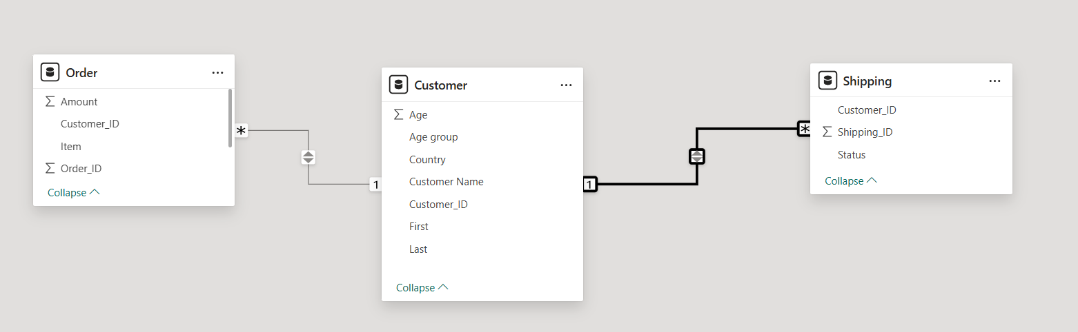
  - The Customer table is connected with the Order and Shipping table on the Customer_ID column.
  - We can also add a merged dataset where the fact data such as Shipping ID, Order ID, Customer ID, Item id (New identifier for the item column), Amount, Number of Quantity Sold Columns can be merged into one table.

  - The dimension tables Customers (Customer ID, Customer Name (First & Last Name Combined), Age, Age Group, Country), Item Table (Item id, Item Name, Amount) and Shipping (Shipping Id, Shipping Status) can be created.

SQL Code Snippet for Dimension Tables:
-- DIM_CUSTOMER
CREATE VIEW DIM_CUSTOMER AS
SELECT
Customer_ID,
CONCAT(First, ' ', Last) AS Customer_Name,
Age,
CASE WHEN Age < 30 THEN '<30' ELSE '≥30' END AS Age_Group,
Country
FROM Customer;

-- DIM_ITEM (Assign synthetic Item_ID)
CREATE VIEW DIM_ITEM AS
SELECT
ROW_NUMBER() OVER (ORDER BY Item) AS Item_ID,
Item AS Item_Name,
AVG(Amount) AS Avg_Price
FROM Orders
GROUP BY Item;

-- DIM_SHIPPING
CREATE VIEW DIM_SHIPPING AS
SELECT DISTINCT
Shipping_ID,
Status AS Shipping_Status
FROM Shipping;

SQL Code Snippet for Fact Table:
-- FACT_SALES
CREATE VIEW FACT_SALES AS
SELECT
s.Shipping_ID,
o.Order_ID,
o.Customer_ID,
i.Item_ID,
o.Amount,
1 AS Quantity_Sold,
FROM Orders o
JOIN Shipping s ON o.Order_ID = s.Shipping_ID
JOIN DIM_ITEM i ON o.Item = i.Item_Name
LEFT JOIN Customer c ON o.Customer_ID = c.Customer_ID;

The relationship after modifying the data would look like as follows:
- Link FACT_SALES to dimensions:
  - FACT_SALES[Customer_ID] → DIM_CUSTOMER[Customer_ID]
  - FACT_SALES[Item_ID] → DIM_ITEM[Item_ID]
  - FACT_SALES[Shipping_ID] → DIM_SHIPPING[Shipping_ID]

The above data model follows a Star Schema Model where Fact View remains in the center and the dimensional views are spread across the fact view enabling the data model to perform efficiently.

Key Benefits of This Model
- Performance: Star schema optimizes query speed.
- Scalability: Easy to add new dimensions (e.g., time, promotions).
- Consistency: Single source of truth for metrics like Amount.

